 

TripAdvisor E-Management

College:7136 - SREE SAKTHI ENGINEERIMG COLLEGE

Team ID: NM2024TMID04970

TeamLead:POORNIMA.P 6C55743F4DF70A2BCC340A9506AA791E

Team Members:

|  |  |
| --- | --- |
| POORNIMA P | 6C55743F4DF70A2BCC340A9506AA791E |
| IMMANUVEL GNANARAJ P | AF3000FD1BB905790AD41499A3E783C4 |
| JEEVITHA A | B59F27D95AC17EC0B6ED4CEDB08B90B9B |
| PREMA K | B232A095BA90DEA88064A98909C58131 |
|  |  |

# ProjectOverview

TheTripAdvisorE-Managementapp integrateswithSalesforce tocreatea

comprehensivetravelcompanion.Theappenablesuserstoplan,book,andoptimize theirtravel experiencesby managing informationrelated tohotels, flights,and food options. The platform facilitates informed travel decisions, leveraging millions of

reviewsandinsightstosupportthebestchoicesinaccommodations,dining, attractions, and deals.

# Objectives

**BusinessGoals:**

* + Enhancetheefficiencyanduserexperienceofthetravelmanagement process.
  + Automatedatamanagementtasks,discountapplication,andemail notifications for timely customer engagement.
  + Provideseamlesstrackingandupdatestoensureaccurateinformationon hotels, food options, and flight details.

# SpecificOutcomes:

* + - Automatedsynchronizationbetweenfoodoptionsandhotelstoensure accurate hotel data.
    - Adynamicdiscountsystemforcustomersbasedontheirspending, enhancing customer satisfaction.
    - Scheduledemailalertsforflightbookingstoensuretimelynotifications, improving customer travel experience.

# SalesforceKeyFeaturesandConceptsUtilized

ThisprojectleverageskeySalesforcefunctionalitiesandconceptstocreatea seamless and effective food distribution system:

## CustomObjectsandFields

* **Hotel**:Storeshoteldetails,includingassociatedfoodoptions.
* **FoodOption**:Tracksavailablefoodchoicesperhotel(AutoNumber: FO-{0000}).
* **Flight**:Recordscustomerflightdetails(AutoNumber:FL-{0000}).
* **Customer**:Managescustomerdetailsfordiscounteligibility.

## FlowforDiscounts

CreatedaFlowtoapplyautomaticdiscountsbasedoncustomerspending:

* **Spending>3000**:Applyhigherdiscountrate.
* **Spendingbetween1500and3000**:Applylowerdiscountrate.

## ApexTriggersforDataSynchronization

* **Hotel-FoodOptionSynchronization:**DevelopedanApextriggerthat updates hotel information whenever a new food option is added or modified, ensuring accurate food count per hotel.

## ApexSchedulableClassforFlightReminders

Createdan**ApexSchedulableclass**toautomateemailremindersfor customers with booked flights.

* **ReminderSchedule:**Sendsanemailnotification24hoursbefore departure.
* **Confirmation:**Systemprovidesconfirmationthattheemailwassent successfully.

TheseSalesforcefeaturescollectivelyensurethattheprojectoperateswithhigh efficiency, transparency, and data-driven decision-making to maximize food

distributioneffectiveness.

# DetailedStepstoSolutionDesign

* **Createdobjects**
  + Inthesalesforcedeveloperplatform,wecreatedcustomobjectsthat were required for the project.
  + Therewere4mainobjects
  + TheywereHotel,Flight,FoodOption,Customer.
  + Thiswasdonebyusingtheobjectmanager

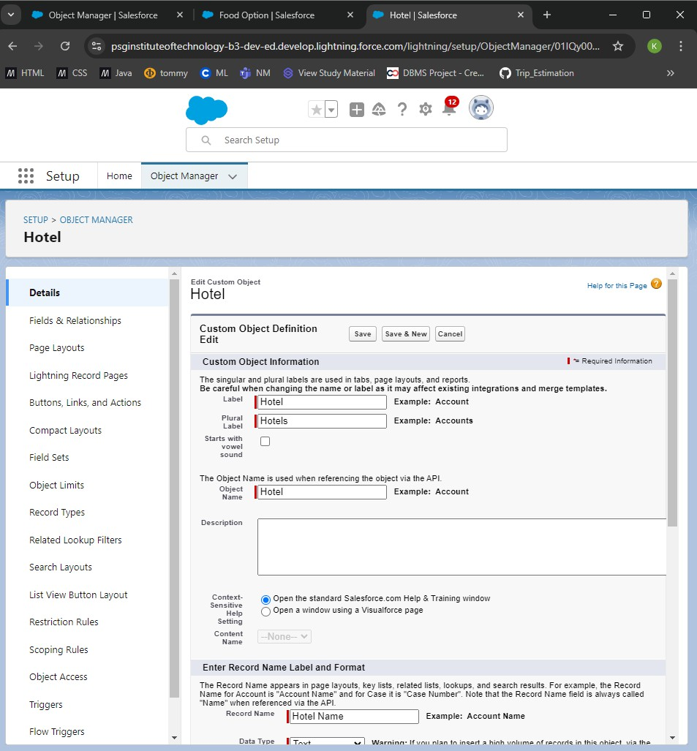

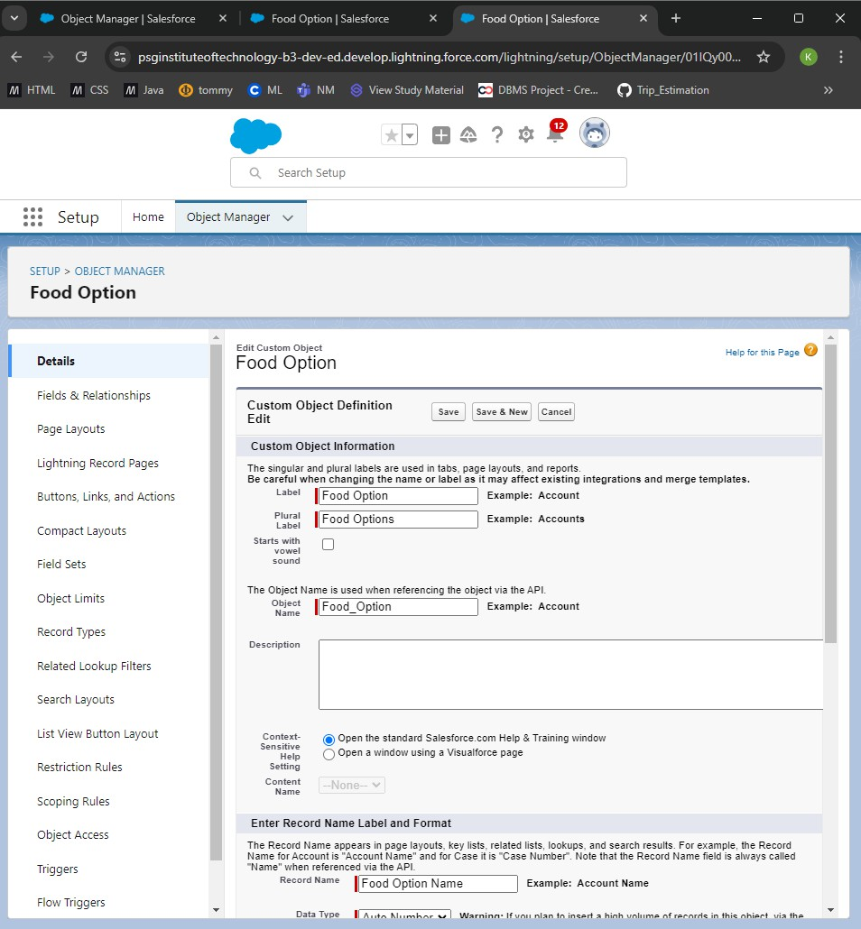

# Createdfieldsforhotelobject

* + TotalFoodOptionswithdatatypeasnumber
  + Datewithdatatypeasdate

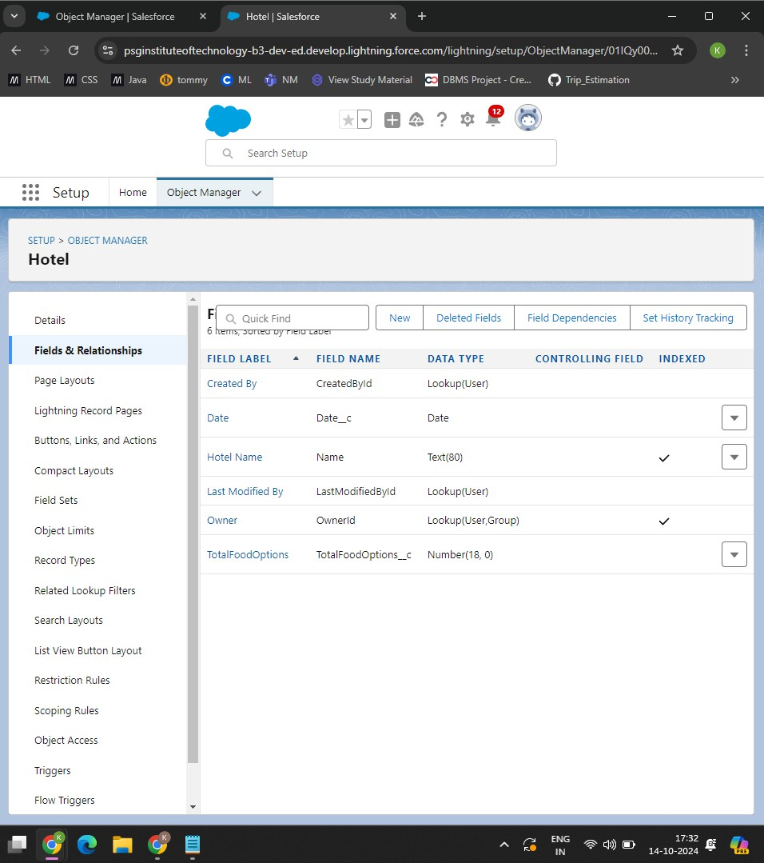

# CreateFieldsforFoodOption

* + FoodAmount
  + Hotel
  + Name

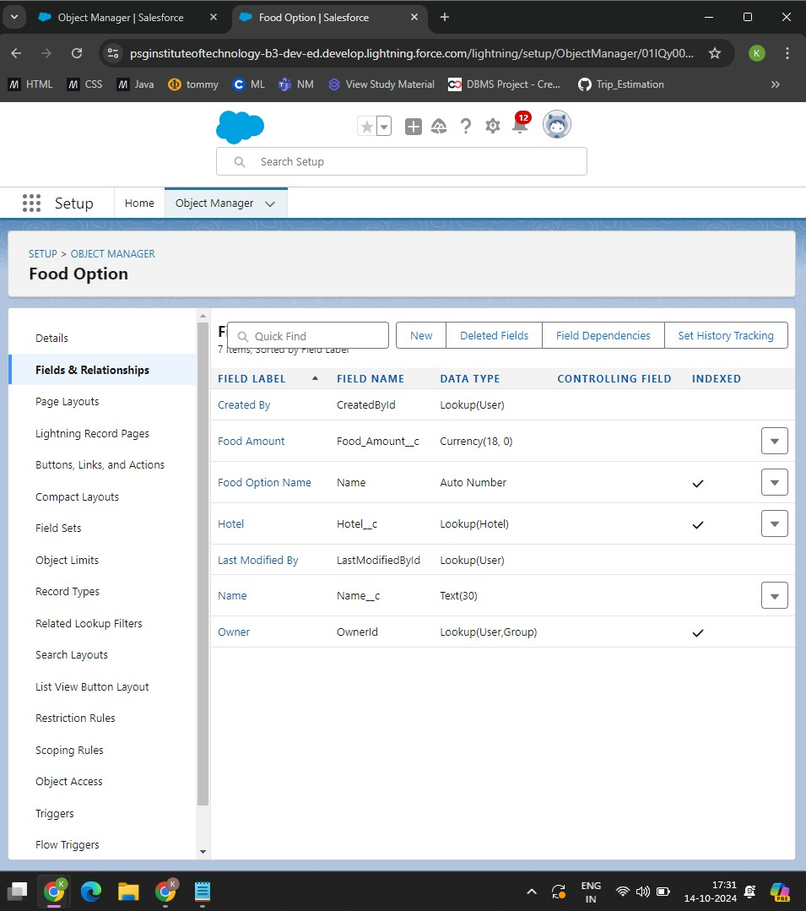

# CreatedFieldsforFlightobject

* + Name
  + DepartureDateTime

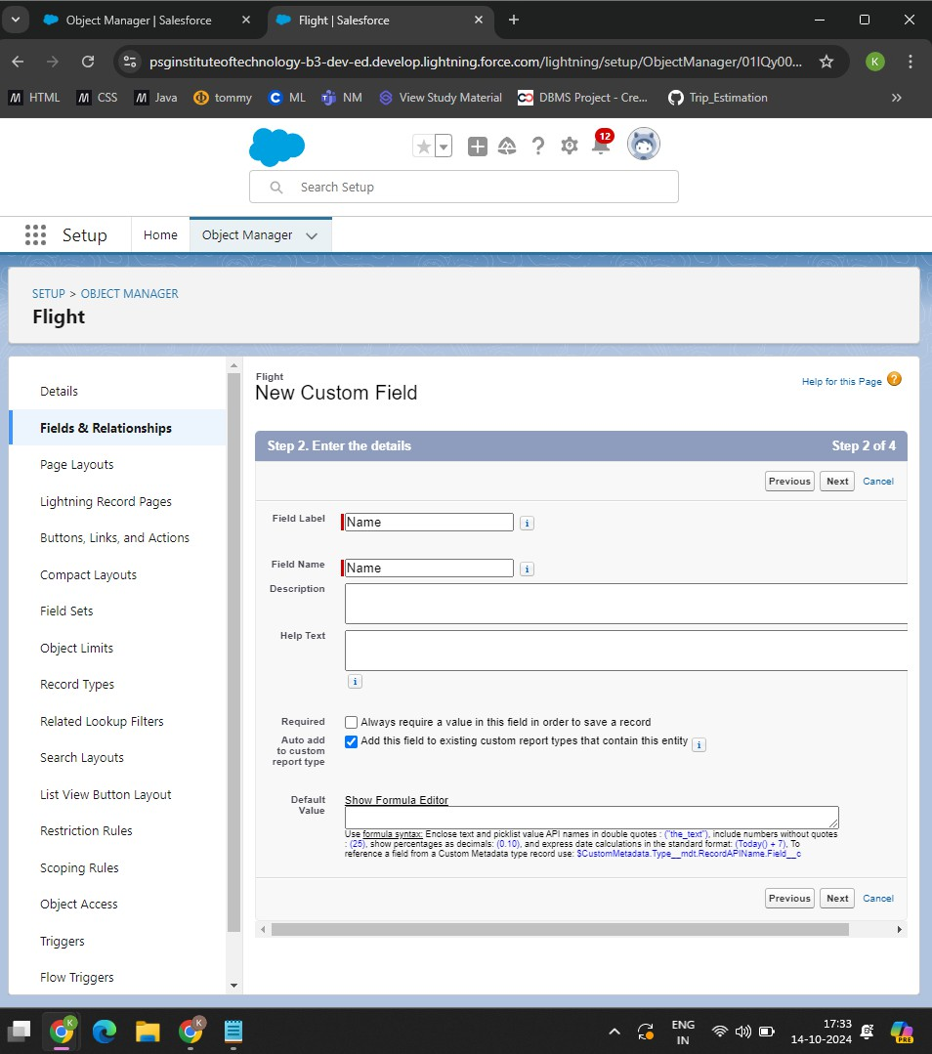

# Createdfieldsforcustomerobject

* + Customername
  + Discountamount
  + Discountpercentage

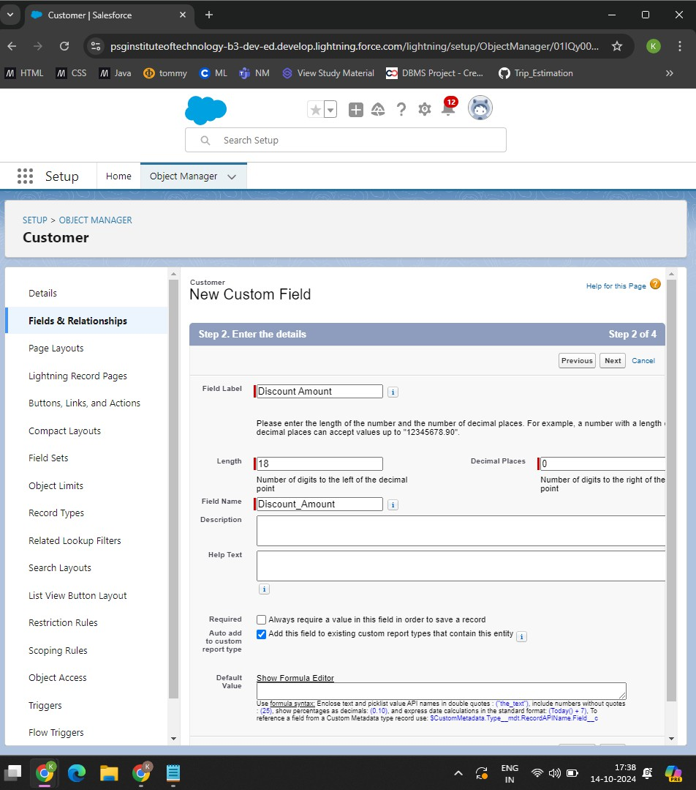

# CreatedFlow

* + Developed a **Discount Flow** to automatically apply discounts based on customerpurchaseamounts.Thisflowappliesdiscountsinastep-by-step format to ensure ease of entry and accuracy.
  + **FlowConditions**:Theflowistriggeredwhenthecustomerpurchase**Amount**

meetsspecificthresholds:

* + - Forpurchasesgreaterthan**3000**,ahighdiscountrateisapplied.
    - Forpurchasesbetween**1500and3000**,amediumdiscountrateis applied.

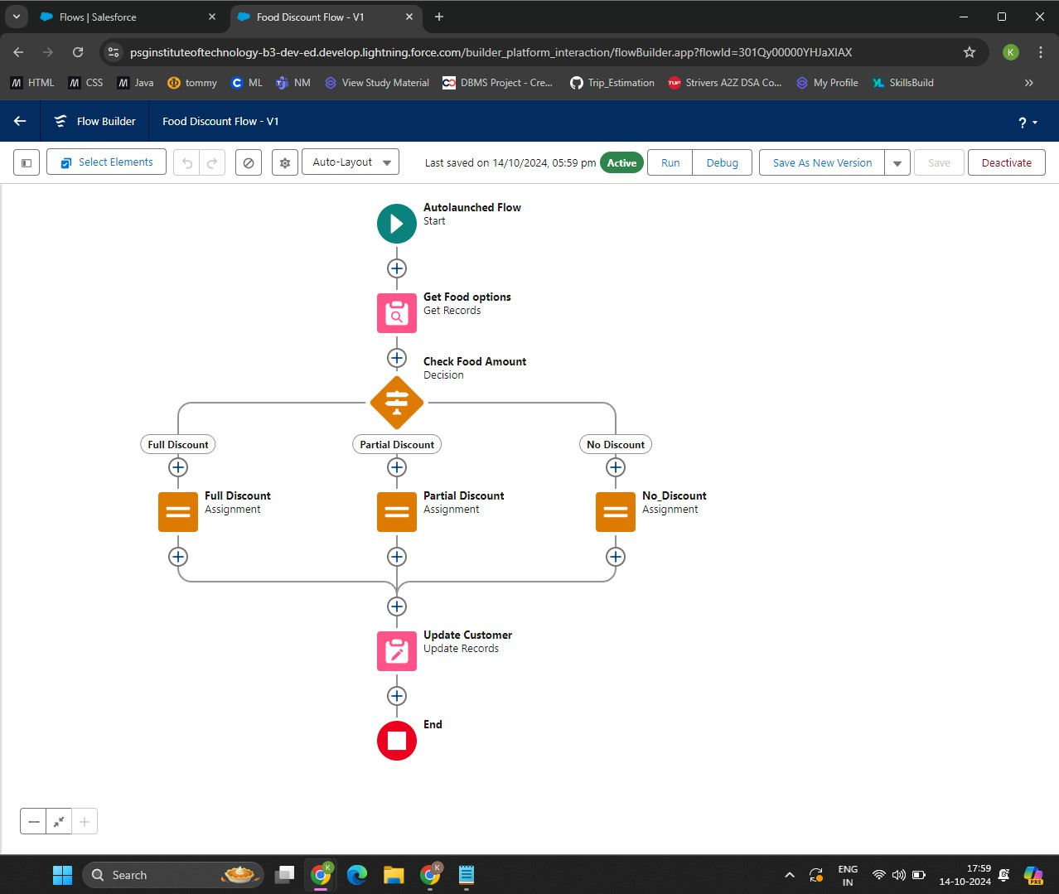

# CreatedApexTriggerforFoodOption

* + Developed an **Apex Trigger** to ensure synchronization between **Hotel** and**FoodOption**records,maintainingclearandmanageablerecordsof food options available at each hotel.
  + Trigger Conditions: The trigger is activated whenever a **Food Option** recordisaddedorupdatedtoreflectchangesintheassociated**Hotel** record.

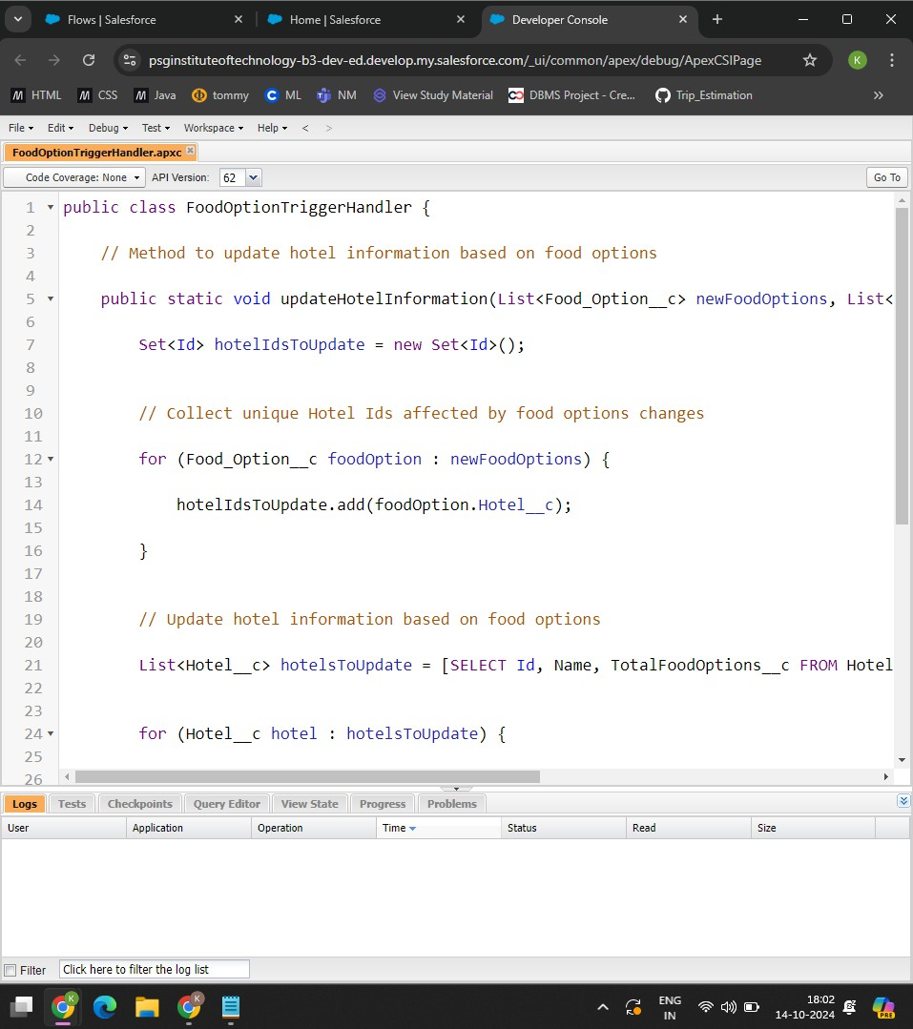



# CreatedApexSchedule

* + Developedan **ApexSchedule**tosendreminderemailstocustomerswhohave booked flights, ensuring they receive a notification 24 hours before their scheduled flight.
  + The**ApexSchedule**issettorundailyandcheckforflightbookingsscheduled within the next 24 hours.
  + Ifthebookingiswithin24hours,an **emailalert**istriggeredtoremindthe customer of their upcoming flight.

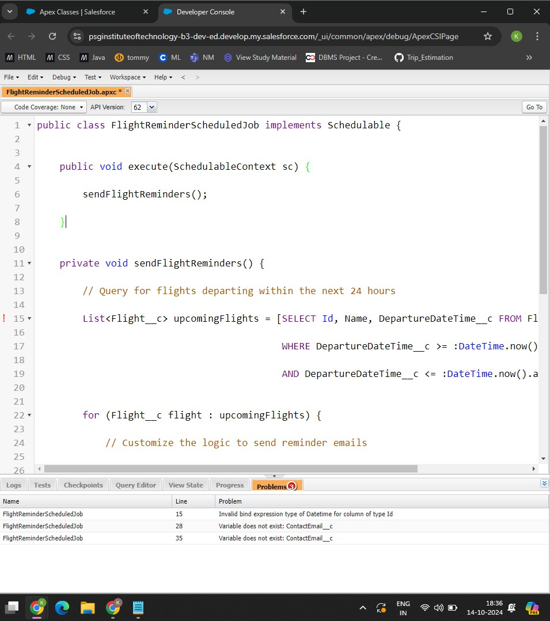

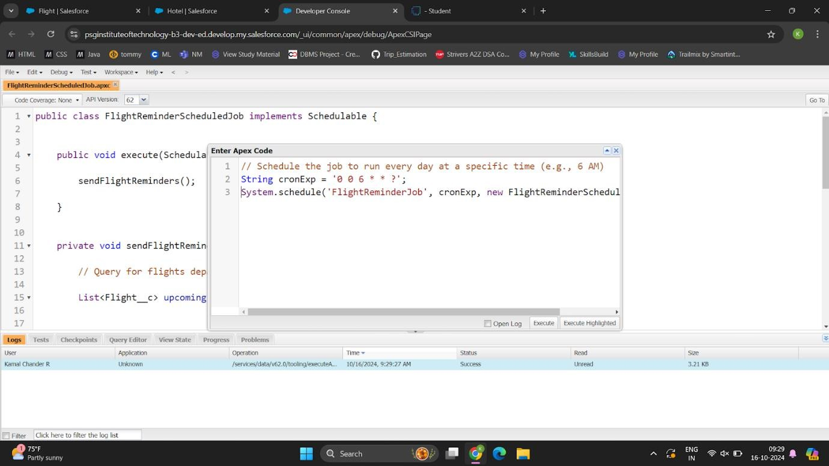

# TestingandValidation Apex Trigger:

triggerFoodOptionTriggeronFood_Optionc(afterinsert,afterupdate,after delete) {

if(trigger.isInsert&&trigger.isAfter){

FoodOptionTriggerHandler.updateHotelInformation(trigger.new);

}

}

# TestClass:

@isTest

privateclassTestFoodOptionTrigger{

@isTeststaticvoidtestFoodOptionTrigger() {

//CreateaHotelrecordforreference

Hotelchotel=newHotelc(Name='TestHotel'); insert hotel;

//CreateaFoodOptionrecordlinkedtotheHotel

Food_OptioncfoodOption1=newFood_Optionc(Hotelc=hotel.Id); insert foodOption1;

//VerifyifHotel'sTotalFoodOptionscisupdatedcorrectly

HotelcupdatedHotel=[SELECTTotalFoodOptionscFROMHotelcWHEREId = :hotel.Id];

System.assertEquals(1,updatedHotel.TotalFoodOptionsc, 'TotalFoodOptionsc should be updated to 1');

//CreateanotherFoodOptionandcheckthecountagain

Food_OptioncfoodOption2=newFood_Optionc(Hotelc=hotel.Id); insert foodOption2;

updatedHotel=[SELECTTotalFoodOptionscFROMHotelcWHEREId=

:hotel.Id];

System.assertEquals(2,updatedHotel.TotalFoodOptionsc, 'TotalFoodOptionsc should be updated to 2');

}

}

# STEPS:

Step1:CreatesaHotelcrecordwithTotalFoodOptionscinitializedto0. Step 2: Inserts a Food_Optionc record associated with the hotel.

Step3:VerifiesthatTotalFoodOptionsconthehotelisupdatedto1afteradding the first food option.

Step4:AddsanotherFood_OptionctocheckifTotalFoodOptionscincrementsto 2.

Step5:Updatesafoodoptionrecordtoconfirmthatupdatesdonotaffectthecount.

Step6:DeletesoneFood_OptioncandverifiesthatTotalFoodOptionsc decrements accordingly.

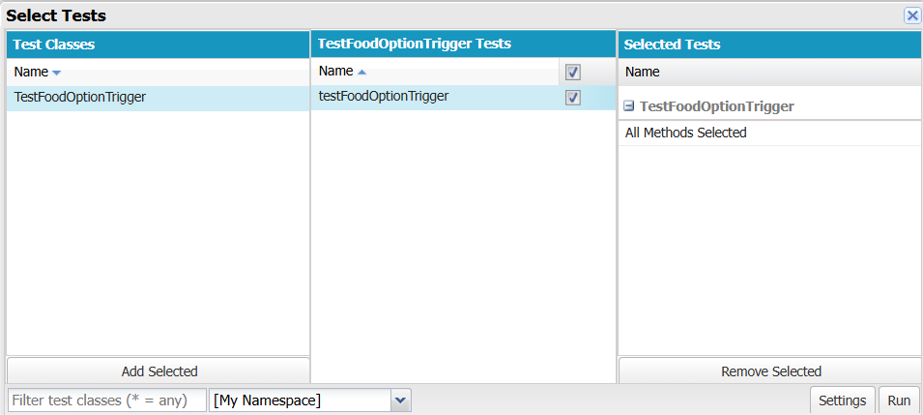

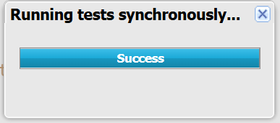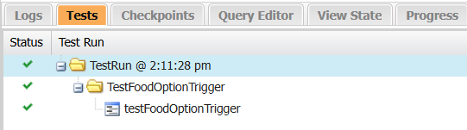

# Conclusion

## SummaryofAchievements:

The**TripAdvisorE-Management**projectsuccessfullyestablishedanall-in-onetravel management platform on Salesforce. Key achievements include:

* + **Comprehensive Data Management**: Created custom objects and fields to manageessentialtraveldata,supportingorganizedandaccessiblerecords.
  + **AutomatedProcesses**:UsedflowsandApextriggerstoenhanceoperational efficiency, reducing manual input and improving data accuracy.
  + **EnhancedCollaboration**:Configuredprofilesandpublicgroupstoallowsecure collaboration, protecting data privacy.
  + **Real-TimeMonitoring**:Developedcustomreportsandacentralized dashboard for real-time insights into booking trends and customer preferences.
  + **ImprovedDecision-Making**:Createdastreamlined,user-friendlysystemthat supports seamless travel planning and booking, enabling quick, informed

decision-makingforusers.

ThisprojectdemonstratestheeffectiveuseofSalesforcetosupportadynamic,user- centeredtravelmanagementsolution,makingTripAdvisoraninvaluableresourcefor travelers.